Early Project Documentation: StudyTrack, a Personal Study Planner and Task Tracker
Draven Chen
Southern New Hampshire University
Software Engineering
August 6, 2026

Project Description
StudyTrack is a lightweight web application that helps college students organize coursework, plan study time, and monitor their own academic progress in one place. Students create tasks and study sessions tied to specific courses, receive reminders before deadlines, and view a personal dashboard summarizing completion rates and hours studied. The system is intentionally scoped to a single-user planning tool rather than a full learning management system, keeping the data model and feature set manageable for an initial release. A basic administrator role is included to manage the course list and user accounts, but the core value of the product is the student-facing planning and tracking experience.

Functional and Non-Functional Requirements

Functional Requirements
FR1: Task Creation and Management
Requirement statement: The system shall allow a student to create, edit, mark complete, and delete tasks, each with a title, description, due date, priority, and associated course.
Rationale: Early interviews with fellow students identified missed or forgotten assignments as the most common source of avoidable grade loss. A flexible task record with a due date and priority field directly addresses that stakeholder need, and editing/deletion support acknowledges that plans change throughout a term. Without this baseline capability, none of the other planning or reminder features would have anything to operate on.
FR2: Study Session Scheduling
Requirement statement: The system shall allow a student to schedule study sessions with a start time, end time, topic, and linked course, and to mark sessions as completed.
Rationale: Students reported that they plan study time informally (sticky notes, phone reminders) and rarely track whether planned sessions actually happen. Capturing scheduled sessions as first-class records lets the system later compute study-time analytics and supports the constraint that the tool must reflect real behavior, not just intentions. This requirement also lays the groundwork for the progress dashboard.
FR3: Reminders and Notifications
Requirement statement: The system shall let a student set a reminder for a task or study session and shall notify the student at the configured trigger time.
Rationale: Deadline-driven stress was a recurring theme in early stakeholder conversations, and a proactive reminder was the single most requested feature. Tying reminders to existing tasks and sessions (rather than a separate free-standing notification system) keeps the data model simple while still meeting the underlying need: students want to be warned before it is too late to act.
FR4: Progress Dashboard
Requirement statement: The system shall generate a dashboard showing the student's task completion rate and total study hours, filterable by course and date range.
Rationale: Several students noted that seeing progress, not just a to-do list, is what keeps them motivated over a full semester. This requirement translates that insight into a concrete, testable feature and gives the project a natural home for future analytics work without requiring changes to the underlying task and session data structures.

Non-Functional Requirements
NFR1: Performance and Responsiveness
Requirement statement: Core actions (creating a task, loading the dashboard, viewing a course's sessions) shall complete in under two seconds under normal load for a single user.
Rationale: Because students will often open the app between classes or before a deadline, a slow interface undermines the exact use case the tool is meant to support. A two-second budget is a reasonable early constraint for a single-user planning tool and gives the development team a concrete target to design and test against, rather than treating performance as an afterthought.
NFR2: Data Security and Privacy
Requirement statement: The system shall store passwords using a salted hash, transmit data over HTTPS, and restrict each student's data so it is visible only to that student and, where applicable, an administrator.
Rationale: Academic task and schedule data can reveal sensitive information about a student's workload and habits, and account credentials are an obvious attack target for any web-facing tool. This requirement reflects both a general engineering constraint (never store plaintext passwords) and a stakeholder expectation that a personal planning tool should not leak information between accounts.

UML Diagrams
The diagrams below model StudyTrack's primary actors and interactions (use case diagram) and its core data structure and responsibilities (class diagram). Both diagrams were derived directly from the functional requirements above: every functional requirement maps to at least one use case, and every noun in a requirement maps to a class or attribute.

Use Case Diagram
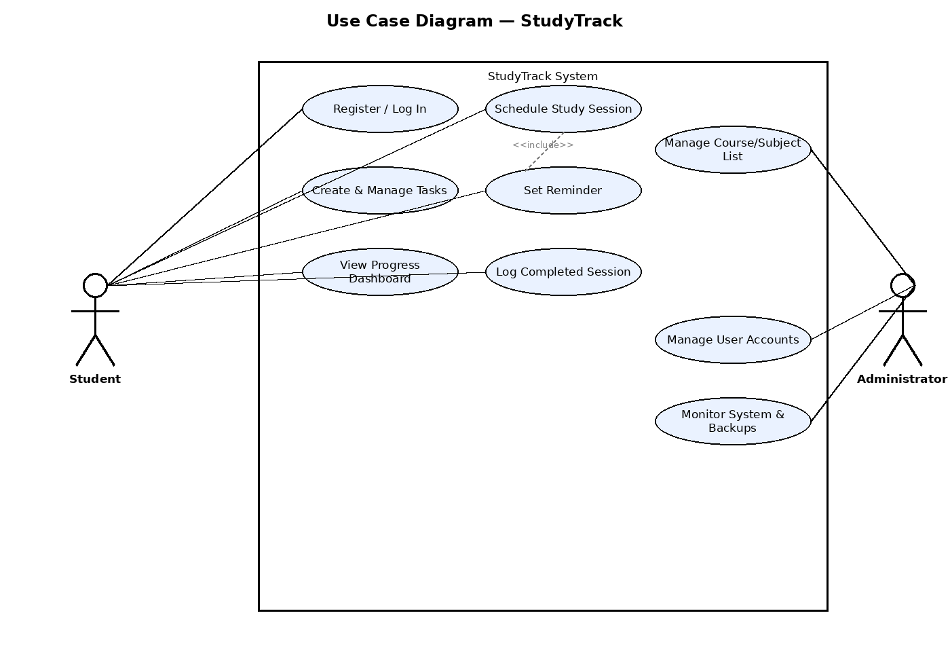
Figure 1. Use case diagram showing the Student and Administrator actors and their interactions with the StudyTrack system.

Class Diagram
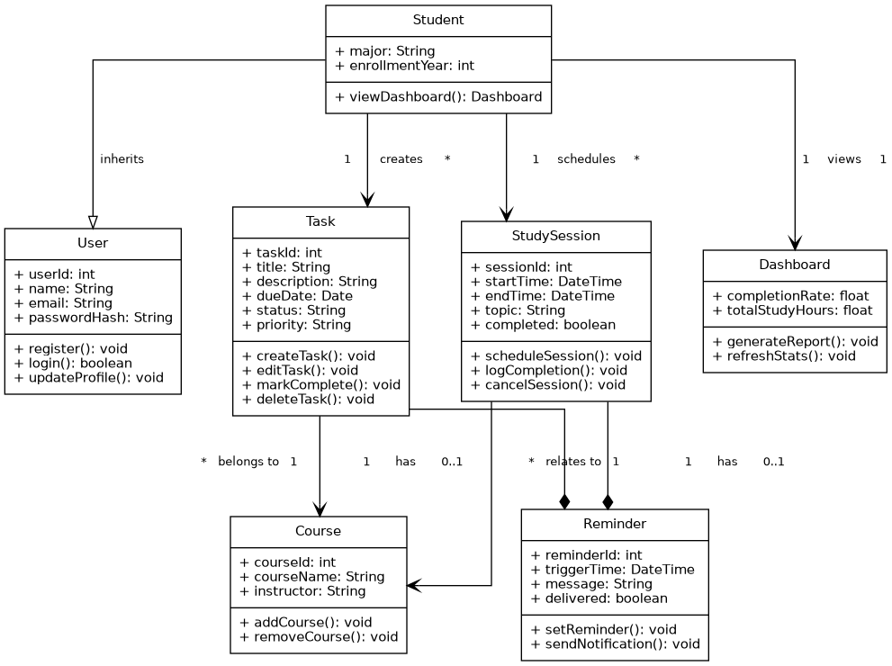
Figure 2. Class diagram showing StudyTrack's core classes, attributes, operations, and relationships.

Product Backlog
The user stories below translate the requirements into backlog items written from the student's point of view. Each includes acceptance criteria that will later support test-case design and sprint review.
US1: As a student, I want to create a task with a due date and priority, so that I can keep track of upcoming assignments in one place.
Acceptance Criteria:
- Given valid input, a new task is saved with title, due date, priority, and course.
- The task appears in the student's task list immediately after creation.
- Required fields (title, due date) cannot be left blank.
US2: As a student, I want to mark a task as complete, so that my dashboard accurately reflects my progress.
Acceptance Criteria:
- Marking a task complete updates its status and completion timestamp.
- Completed tasks are visually distinguished from open tasks in the task list.
- The dashboard's completion rate recalculates after the status change.
US3: As a student, I want to schedule a study session linked to a course, so that I can plan dedicated study time around my coursework.
Acceptance Criteria:
- A session requires a start time, end time, topic, and course.
- The system rejects a session whose end time is before its start time.
- Scheduled sessions appear in a calendar or list view sorted by date.
US4: As a student, I want to set a reminder for a task or session, so that I do not forget an approaching deadline or planned study block.
Acceptance Criteria:
- A reminder can be attached to any existing task or session.
- The student receives a notification at the configured trigger time.
- A delivered reminder is marked as sent and is not re-sent.
US5: As a student, I want to view a dashboard of my completion rate and study hours, so that I can gauge whether I am keeping up with my workload.
Acceptance Criteria:
- The dashboard displays completion rate and total study hours.
- Results can be filtered by course and by date range.
- The dashboard reflects data updates within the same session (no manual refresh required).
US6: As an administrator, I want to manage the course list, so that students always choose from an accurate set of active courses.
Acceptance Criteria:
- An administrator can add, edit, and deactivate a course.
- Deactivated courses no longer appear as options for new tasks or sessions.
- Existing tasks/sessions linked to a deactivated course remain visible for the student.

Sprint Planning Documentation
Sprint 1 focuses on the smallest set of stories that produces a usable, testable slice of the product: creating tasks, completing tasks, and viewing the resulting progress on a dashboard. Scheduling, reminders, and course administration are deferred to later sprints once this core loop is validated.
User Story | Task | Estimated Effort | Timeline | Tools / Resources
US1 | Design Task data model and database schema | 3 hrs | Day 1 | Draw.io, SQLite
US1 | Build task creation form and validation | 5 hrs | Days 1–2 | React, VS Code
US1 | Implement save-task API endpoint | 4 hrs | Day 2 | Node.js, Express
US2 | Add complete/incomplete toggle to task list UI | 3 hrs | Day 3 | React
US2 | Implement status-update API endpoint | 3 hrs | Day 3 | Node.js, Express
US5 | Build dashboard query for completion rate | 4 hrs | Day 4 | SQL, Node.js
US5 | Build dashboard UI (completion rate view) | 5 hrs | Days 4–5 | React, Chart library
US1/US2/US5 | Manual test pass and bug fixes | 4 hrs | Day 5 | Browser dev tools, test checklist

This sprint structure follows the Agile/Scrum model, using short, fixed-length iterations that each deliver a working, demonstrable increment of the product. Scrum was chosen over a plan-driven model such as Waterfall because the requirements above, while reasonably clear, are still likely to shift once a real student uses the task-and-dashboard loop; Scrum's short feedback cycle lets the team validate assumptions (for example, whether the dashboard's completion-rate calculation is actually meaningful to students) after one week rather than after the entire system is built. A one-week, single-developer sprint also matches the manageable scope of this project: it is long enough to complete a vertical slice of functionality (data model through UI) but short enough to re-plan quickly if a task takes longer than estimated.

Reflection
Working through requirements before writing any code made clear how much a single ambiguous phrase can ripple through a project. Early on, "track study time" could have meant either a timer feature or a scheduling feature, and choosing the scheduling interpretation changed the shape of the class diagram, the backlog, and the sprint plan that followed. Writing a rationale for each requirement was more useful than expected: it forced a concrete answer to "who needs this and why," which caught at least one requirement (an early idea for social/leaderboard features) that had no real stakeholder justification and was dropped. Building the use case and class diagrams side by side also surfaced a design question I had not considered — whether a reminder belongs to a task/session or exists independently — and settling that in the model prevented an inconsistency from reaching the backlog. Looking ahead, my main concerns are scope creep around the dashboard (analytics features can expand indefinitely) and data integrity if a course is deleted while tasks still reference it. Both are manageable at this stage precisely because they were identified early, before any code commits them to a particular structure, which is the core argument for doing this documentation up front rather than retrofitting it later.

